Introduction
This webservice used for communicating between InitDine and intGuest . This will only required if client required both InitDine, intGuest.

SETUP PMS WEB SERVICE

- Download the intGuest web service or Pull(Clone) the Repository using following command
  - git clone https://github.com/indocosmo-projects/InitGuest-Webservice.git

- Create a folder pmsweb workspace

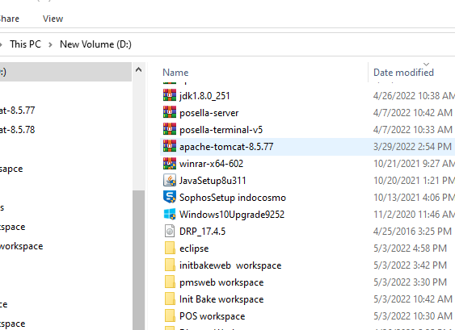

- Extract rar file to pmsweb workspace

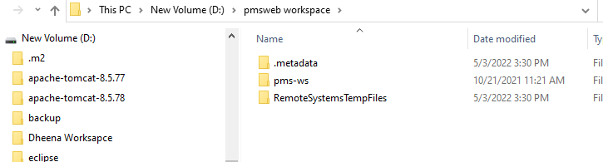

- Open eclipse with pmsweb workspace

- Then import using file--->import-->exsisting file-->select location -->finish
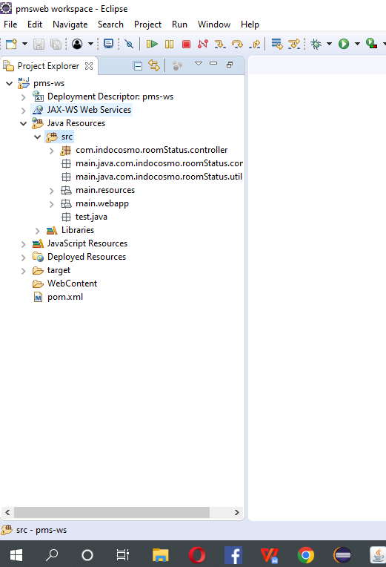

DB Configuration Setup
- Select src-->main-->resources and open the database.properties file
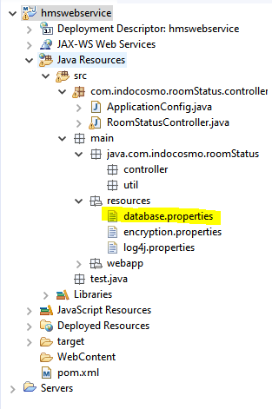
- Give the correct DB details.
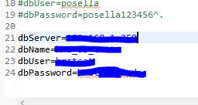
- Save the file

War Build Procedure

- Right click the project --> Select Export-->Choose War file

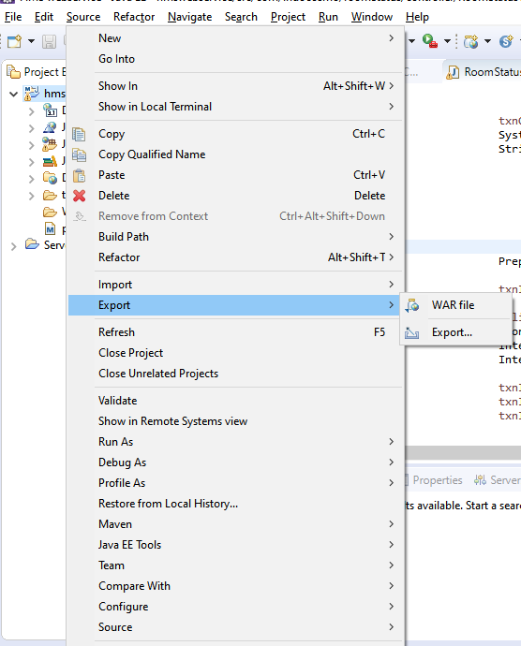

- Select the desired location for war files to save.

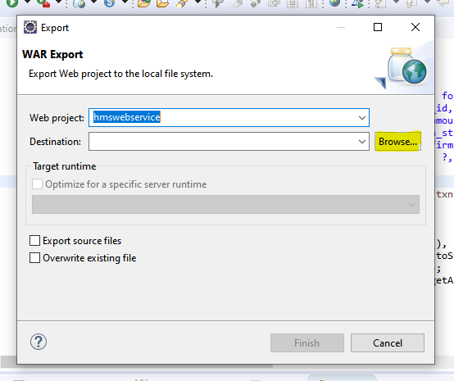

- Save the War file 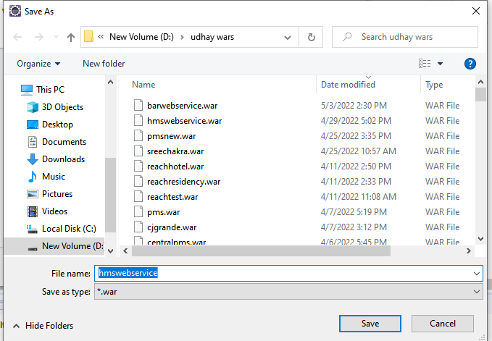

- Click Finish Button
